**Ex No: 1 a**

**Date: 20.2.2024**

**INSTALLATION AND CONFIGURATION OF LINUX**

**Aim:**

To install and configure Linux operating system in a Virtual Machine. **Installation/Configuration Steps:**

1. Install the required packages for virtualization

**dnf install xen virt-manager qemu libvirt**

2. Configure xend to start up on boot

**systemctl enable virt-manager.service**

3. Reboot the machine

**Reboot**

4. Create Virtual machine by first running virt-manager

**virt-manager &**

5. Click on File and then click to connect to localhost

6. In the base menu, right click on the localhost(QEMU) to create a new VM 7. Select Linux ISO image

8. Choose puppy-linux.iso then kernel version

9. Select CPU and RAM limits

10.Create default disk image to 8 GB

11.Click finish for creating the new VM with PuppyLinux

**Output:**

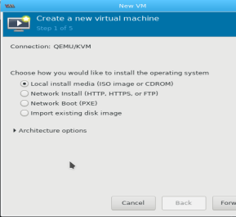

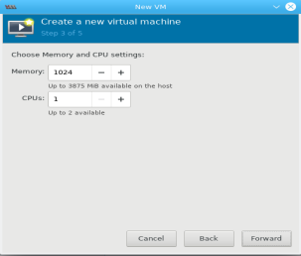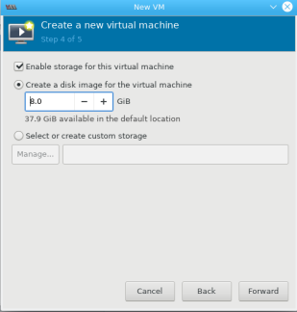4

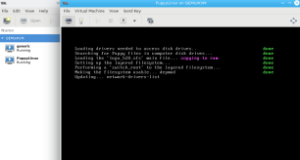**RESULT:**

Installation and configuration executed successfully

**Ex No: 1 b**

**Date: 27.2.2024**

**BASIC LINUX COMMANDS**

**1.1 GENERAL PURPOSE COMMANDS**

1. The ‘date’ command:

The date command display the current date with day of week, month, day, time (24 hours clock) and the year.

**SYNTAX:** $ date

The date command can also be used with following format.

|  |  |  |
| --- | --- | --- |
| Format | Purpose | Example |
| + %m | To display only month | $ date + %m |
| + %h | To display month name | $ date + %h |
| + %d | To display day of month | $ date + %d |
| + %y | To display last two digits of the year | $ date + %y |
| + %H | To display Hours | $ date + %H |
| + %M | To display Minutes | $ date + %M |
| + %S | To display Seconds | $ date + %S |

**OUTPUT**



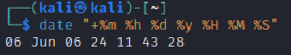

2. The echo’command:

The echo command is used to print the message on the screen. **SYNTAX**: $ echo

EXAMPLE: $ echo “God is Great”

**OUTPUT**

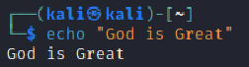

3. The ‘cal’ command:

The cal command displays the specified month or year calendar. **SYNTAX:** $ cal [month] [year]

EXAMPLE: $ cal Jan 2012

**OUTPUT**

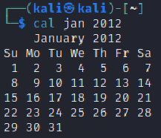

4. The ‘bc’ command:

Unix offers an online calculator and can be invoked by the command bc.

**SYNTAX:** $ bc

EXAMPLE: bc –l

16/4

5/2

**OUTPUT**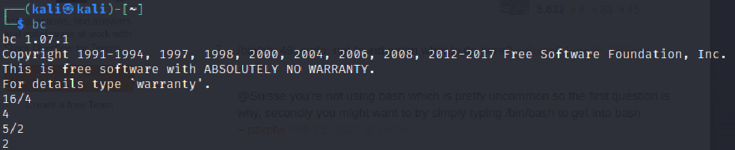

5. The ‘who’ command

The who command is used to display the data about all the users who are currently logged into the system.

**SYNTAX:** $ who

**OUTPUT**

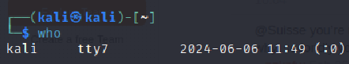

6. The ‘who am i’ command

The who am i command displays data about login details of the user.

**SYNTAX:** $ who am i

**OUTPUT**



7. The ‘id’ command

The id command displays the numerical value corresponding to your login. **SYNTAX:** $ id

**OUTPUT**

****8. The ‘tty’ command

The tty (teletype) command is used to know the terminal name that we are using. **SYNTAX:** $ tty

**OUTPUT**

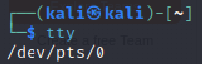

9. The ‘clear’ command

The clear command is used to clear the screen of your terminal.

**SYNTAX:** $ clear

**OUTPUT**

This command clear the terminal

10. The ‘man’ command

The man command gives you complete access to the Unix commands.

**SYNTAX:** $ man [command]

**OUTPUT**

This command will give detail of command11. The ‘ps’ command

The ps command is used to the process currently alive in the machine with the 'ps' (process status) command, which displays information about process that are alive when you run the command. 'ps;' produces a snapshot of machine activity.

**SYNTAX:** $ ps

EXAMPLE: $ ps

$ ps –e

$ps –aux

**OUTPUT**

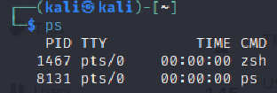

12. The ‘uname’ command

The uname command is used to display relevant details about the operating system on the standard output.

-m -> Displays the machine id (i.e., name of the system hardware)

-n -> Displays the name of the network node. (host name)

-r -> Displays the release number of the operating system.

-s -> Displays the name of the operating system (i.e.. system name)

-v -> Displays the version of the operating system.

-a -> Displays the details of all the above five options.

**SYNTAX:** $ uname [option]

EXAMPLE: $ uname –a

**OUTPUT**



**1.2 DIRECTORY COMMANDS**

1. The ‘pwd’ command:

The pwd (print working directory) command displays the current working directory.

**SYNTAX:** $ pwd

**OUTPUT**

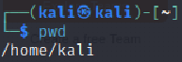

2. The ‘mkdir’ command:

The mkdir is used to create an empty directory in a disk.

**SYNTAX:** $ mkdir dirname

EXAMPLE: $ mkdir receee

**OUTPUT**

Creates a directory

3. The ‘rmdir’ command:

The rmdir is used to remove a directory from the disk. Before removing a directory, the directory must be empty (no files and directories).

**SYNTAX:** $ rmdir dirname

EXAMPLE: $ rmdir receee

**OUTPUT**

Removes a directory

4. The ‘cd’ command:

The cd command is used to move from one directory to another. **SYNTAX**: $ cd dirname

EXAMPLE: $ cd receee

**OUTPUT**

Enters the directory

5. The ‘ls’ command:

The ls command displays the list of files in the current working directory. **SYNTAX:** $ ls

EXAMPLE: $ ls

$ ls –l

$ ls –a

**OUTPUT**

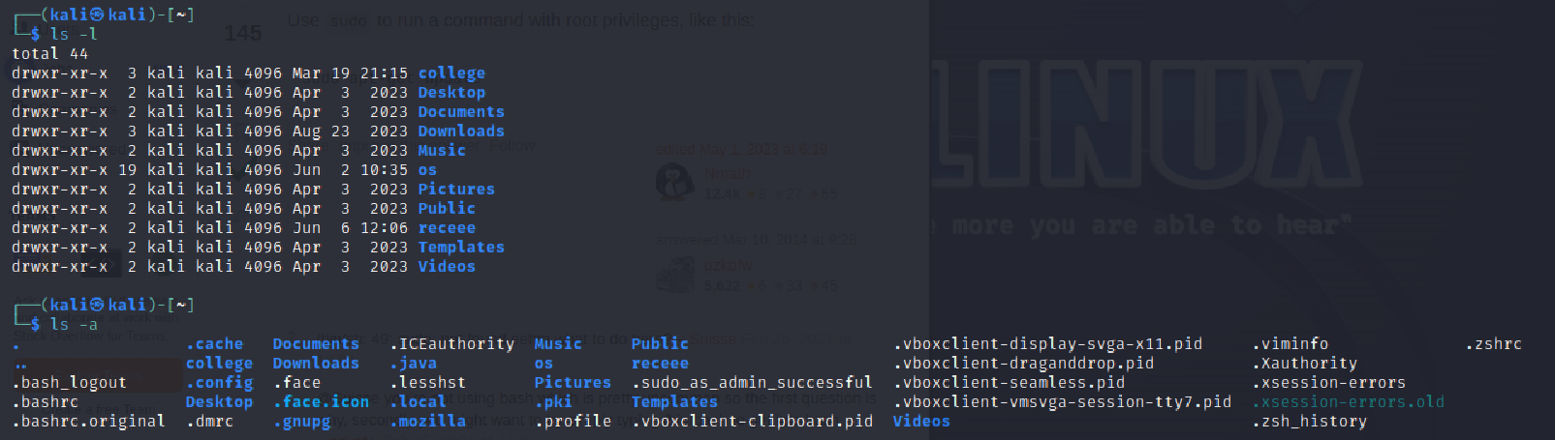

**1.3 FILE HANDLING COMMANDS**

1. The ‘cat’ command:

The cat command is used to create a file.

**SYNTAX:** $ cat > filename

EXAMPLE: $ cat > rec

**OUTPUT**

Create a file named rec

12

2. The ‘Display contents of a file’ command:

The cat command is also used to view the contents of a specified file.

**SYNTAX:** $ cat filename

**OUTPUT**

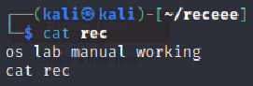

3. The ‘cp’ command:

The cp command is used to copy the contents of one file to another and copies the file from one place to another.

**SYNTAX**: $ cp oldfile newfile

EXAMPLE: $ cp cse ece

**OUTPUT**

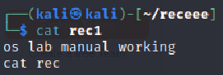

4. The ‘rm’ command:

The rm command is used to remove or erase an existing file

**SYNTAX:** $ rm filename

EXAMPLE: $ rm rec

$ rm –f rec

Use option –fr to delete recursively the contents of the directory and its subdirectories.

**OUTPUT**

Removed file

5. The ‘mv’ command:

The mv command is used to move a file from one place to another. It removes a specified file from its original location and places it in specified location.

**SYNTAX:** $ mv oldfile newfile

EXAMPLE: $ mv cse eee

**OUTPUT**

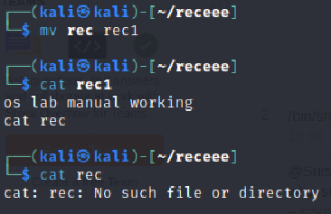

6. The ‘file’ command:

The file command is used to determine the type of file.

**SYNTAX:** $ file filename

EXAMPLE: $ file receee

**OUTPUT**



7. The ‘wc’ command:

The wc command is used to count the number of words, lines and characters in a file. **SYNTAX:** $ wc filename

EXAMPLE: $ wc receee

**OUTPUT**

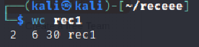

8. The ‘Directing output to a file’ command:

The ls command lists the files on the terminal (screen). Using the redirection operator ‘>’ we can send the output to file instead of showing it on the screen.

**SYNTAX:** $ ls > filename

EXAMPLE: $ ls > cseeee

**OUTPUT**

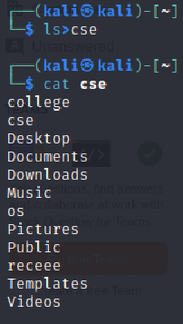

9. The ‘pipes’ command:

The Unix allows us to connect two commands together using these pipes. A pipe ( | ) is an mechanism by which the output of one command can be channeled into the input of another command.

**SYNTAX:** $ command1 | command2

EXAMPLE: $ who | wc –l

10. The ‘tee’ command:

While using pipes, we have not seen any output from a command that gets piped into another command. To save the output, which is produced in the middle of a pipe, the tee command is very useful.

**SYNTAX:** $ command | tee filename

EXAMPLE: $ who | tee sample | wc -l

The ‘Metacharacters of unix’ command:

Metacharacters are special characters that are at higher and abstract level compared to most of other characters in Unix. The shell understands and interprets these metacharacters in a special way.

* - Specifies number of characters

?- Specifies a single character

[ ]- used to match a whole set of file names at a command line.

! – Used to Specify

EXAMPLE:

$ ls r** - Displays all the files whose name begins with ‘r’

$ ls ?kkk - Displays the files which are having ‘kkk’, from the second characters irrespective of the first character.

$ ls [a-m] – Lists the files whose names begins alphabets from ‘a’ to ‘m’

$ ls [!a-m] – Lists all files other than files whose names begins alphabets from ‘a’ to ‘m’

11. The ‘File permissions’ command:

File permission is the way of controlling the accessibility of file for each of three users namely Users, Groups and Others.

There are three types of file permissions are available, they are

**r-read**

**w-write**

**x-execute**

The permissions for each file c ee parts of three bits each. an be divided into thr

|  |  |
| --- | --- |
| First three bits | Owner of the file |
| Next three bits | Group to which owner of the file belongs |
| Last three bits | Others |

EXAMPLE: $ ls college

-rwxr-xr-- 1 Lak std 1525 jan10 12:10 college

Where,

-rwx The file is readable, writable and executable by the owner of the file.

Lak Specifies Owner of the file.

r-x Indicates the absence of the write permission by the Group owner of the file. Std Is the Group Owner of the file.

r-- Indicates read permissions for others.

12. The ‘chmod’ command:

The chmod command is used to set the read, write and execute permissions for all categories of users for file.

**SYNTAX:** $ chmod category operation permission file

|  |  |  |
| --- | --- | --- |
| Category | Operation | permission |
| u-users | + assign | r-read |
| g-group | -Remove | w-write |
| o-others | = assign absolutely | x-execute |
| a-all |  |  |

EXAMPLE:

$ chmod u –wx college

Removes write & execute permission for users for ‘college’ file.

$ chmod u +rw, g+rw college

Assigns read & write permission for users and groups for ‘college’ file. $ chmod g=wx college

Assigns absolute permission for groups of all read, write and execute permissions for ‘college’ file.

13. The ‘Octal Notations’ command:

The file permissions can be changed using octal notations also. The octal notations for file permission are

EXAMPLE:

$ chmod 761 college

|  |  |
| --- | --- |
| Read permission | 4 |
| Write permission | 2 |
| Execute permission | 1 |

Assigns all permission to the owner, read and write permissions to the group and only executable permission to the others for ‘college’ file.

**1.4 GROUPING COMMANDS**

1. The ‘semicolon’ command:

The semicolon(;) command is used to separate multiple commands at the command line.

**SYNTAX:** $ command1;command2;command3…................ ;commandn

EXAMPLE: $ who;date

2. The ‘&&’ operator:

The ‘&&’ operator signifies the logical AND operation in between two or more valid Unix commands.It means that only if the first command is successfully executed, then the next command will executed.

**SYNTAX:** $ command1 && command && command3….................&&commandn EXAMPLE: $ who && date

3. The ‘||’ operator:

The ‘||’ operator signifies the logical OR operation in between two or more valid Unix commands.It means, that only if the first command will happen to be un successfully,it will continue to execute next commands.

**SYNTAX:** $ command1 || command || command3.................... ||commandn EXAMPLE: $ who || date

1.5 FILTERS

1. The head filter

It displays the first ten lines of a file.

**SYNTAX:** $ head filename

EXAMPLE: $ head college Display the top ten lines.

$ head -5 college Display the top five lines.

2. The tail filter

It displays ten lines of a file from the end of the file.

**SYNTAX:** $ tail filename

EXAMPLE: $ tail college Display the last ten lines.

$tail -5 college Display the last five lines.

3. The more filter:

The pg command shows the file page by page.

**SYNTAX:** $ ls –l | more

4. The ‘grep’ command:

This command is used to search for a particular pattern from a file or from the standard input and display those lines on the standard output. “Grep” stands for “global search for regular expression.”

**SYNTAX**: $ grep [pattern] [file_name]

EXAMPLE: $ cat > student

Arun cse

Ram ece

Kani cse

$ grep “cse” student

Arun cse

Kani cse

5. The ‘sort’ command:

The sort command is used to sort the contents of a file. The sort command reports only to the screen, the actual file remains unchanged.

**SYNTAX:** $ sort filename

EXAMPLE: $ sort college

OPTIONS:

|  |  |
| --- | --- |
| Command | Purpose |
| Sort –r college | Sorts and displays the file contents in reverse order |
| Sort –c college | Check if the file is sorted |
| Sort –n college | Sorts numerically |
| Sort –m college | Sorts numerically in reverse order |
| Sort –u college | Remove duplicate records |
| Sort –l college | Skip the column with +1 (one) option.Sorts according to second column |

6. The ‘nl’ command:

The nl filter adds lines numbers to a file and it displays the file and not provides access to edit but simply displays the contents on the screen.

**SYNTAX:** $ nl filename

EXAMPLE: $ nl college

7. The ‘cut’ command:

We can select specified fields from a line of text using cut command.

**SYNTAX:** $ cut -c filename

EXAMPLE: $ cut -c college

OPTION:

-c – Option cut on the specified character position from each line.

**1.5 OTHER ESSENTIAL COMMANDS**

1. **free**

Display amount of free and used physical and swapped memory system.

synopsis- free [options]

example

[root@localhost ~]# free -t

total used free shared buff/cache available

Mem: 4044380 605464 2045080 148820 1393836 3226708

Swap: 2621436 0 2621436

Total: 6665816 605464 4666516

2. **top**

It provides a dynamic real-time view of processes in the system.

synopsis- top [options]

example

[root@localhost ~]# top

top - 08:07:28 up 24 min, 2 users, load average: 0.01, 0.06, 0.23

Tasks: 211 total, 1 running, 210 sleeping, 0 stopped, 0 zombie

%Cpu(s): 0.8 us, 0.3 sy, 0.0 ni, 98.9 id, 0.0 wa, 0.0 hi, 0.0 si, 0.0 st

KiB Mem : 4044380 total, 2052960 free, 600452 used, 1390968 buff/cache KiB Swap: 2621436 total, 2621436 free, 0 used. 3234820 avail Mem

PID USER PR NI VIRT RES SHR S %CPU %MEM TIME+ COMMAND 1105 root 20 0 175008 75700 51264 S 1.7 1.9 0:20.46 Xorg 2529 root 20 0 80444 32640 24796 S 1.0 0.8 0:02.47 gnome-term

3. **ps**

It reports the snapshot of current processes

synopsis- ps [options]

example

[root@localhost ~]# ps -e

PID TTY TIME CMD

1 ? 00:00:03 systemd

2 ? 00:00:00 kthreadd

3 ? 00:00:00 ksoftirqd/0

4. **vmstat**

It reports virtual memory statistics

synopsis- vmstat [options]

example

[root@localhost ~]# vmstat

procs ~~m~~emory ~~s~~wap io-system cpu

r b swpd free buff cache si so bi bo in cs us sy id wa st 0 0 0 1879368 1604 1487116 0 0 64 7 72 140 1 0 97 1 0

5. **df**

It displays the amount of disk space available in file-system.

**S**ynopsis- df [options]

example

[root@localhost ~]# df

Filesystem 1K-blocks Used Available Use% Mounted on

devtmpfs 2010800 0 2010800 0% /dev tmpfs 2022188 148 2022040 1% /dev/shm tmpfs 2022188 1404 2020784 1% /run /dev/sda6 487652 168276 289680 37% /boot

**6. ping**

It is used verify that a device can communicate with another on network. PING stands for Packet Internet Groper.

synopsis- ping [options]

[root@localhost ~]# ping 172.16.4.1

PING 172.16.4.1 (172.16.4.1) 56(84) bytes of data.

64 bytes from 172.16.4.1: icmp_seq=1 ttl=64 time=0.328 ms

64 bytes from 172.16.4.1: icmp_seq=2 ttl=64 time=0.228 ms

64 bytes from 172.16.4.1: icmp_seq=3 ttl=64 time=0.264 ms

64 bytes from 172.16.4.1: icmp_seq=4 ttl=64 time=0.312 ms

^C

--- 172.16.4.1 ping statistics ---

4 packets transmitted, 4 received, 0% packet loss, time 3000ms

rtt min/avg/max/mdev = 0.228/0.283/0.328/0.039 ms

**7. ifconfig**

It is used configure network interface.

synopsis- ifconfig [options]

example

[root@localhost ~]# ifconfig

enp2s0: flags=4163<UP,BROADCAST,RUNNING,MULTICAST> mtu 1500 inet 172.16.6.102 netmask 255.255.252.0 broadcast 172.16.7.255 inet6 fe80::4a0f:cfff:fe6d:6057 prefixlen 64 scopeid 0x20<link>

ether 48:0f:cf:6d:60:57 txqueuelen 1000 (Ethernet)

RX packets 23216 bytes 2483338 (2.3 MiB)

RX errors 0 dropped 5 overruns 0 frame 0

TX packets 1077 bytes 107740 (105.2 KiB)

TX errors 0 dropped 0 overruns 0 carrier 0 collisions 0

**8. traceroute**

It tracks the route the packet takes to reach the destination.

synopsis- traceroute [options]

example

[root@localhost ~]# traceroute www.rajalakshmi.org

traceroute to www.rajalakshmi.org (220.227.30.51), 30 hops max, 60 byte packets 1 gateway (172.16.4.1) 0.299 ms 0.297 ms 0.327 ms

2 220.225.219.38 (220.225.219.38) 6.185 ms 6.203 ms 6.189 ms **RESULT** : The above commands executed successfully and output got verified